Homework 5 – Steffens

Problem 3:

https://umich.maps.arcgis.com/apps/instant/basic/index.html?appid=45e80e37bdc34350935a53356da77036

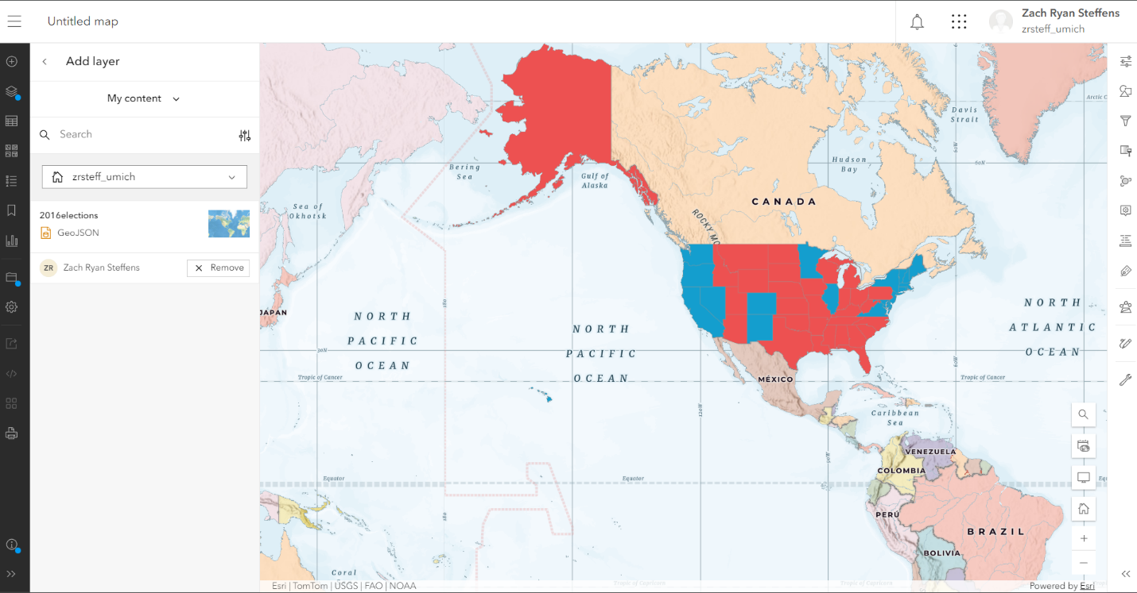

Problem 4:

